EXPT NO: 5 | IMPLEMENTATION OF A RECURRENT NEURAL NETWORK (RNN) FOR TEXT GENERATION
DATE:

PRE-LAB QUESTIONS (PROVIDE BRIEF ANSWERS TO THE FOLLOWING QUESTIONS)

- Explain the purpose of a Recurrent Neural Network (RNN) in processing sequential data.
An RNN is a neural network designed to process sequential data by considering the current input along with information from previous inputs. It maintains a hidden state that stores information about the sequence.
Example: RNNs can process sentences, speech, and time-series data.

- Why is an RNN considered an appropriate model for text generation tasks?
RNNs are suitable for text generation because they can learn the order and relationships between words in a sentence. They use previously processed words to predict the next word.
Example:
Input: I am going to
Prediction: school
- Describe the concept of sequence modeling in natural language processing.
Sequence modeling is the process of analyzing data where the order of elements is important. In NLP, it involves learning relationships between words or tokens in a sentence to understand or generate text.
Example: In “I love machine learning”, the order of the words affects the meaning.
- Explain the importance of tokenization during text preprocessing for RNN-based text generation.

Tokenization divides text into smaller units called tokens, usually words or subwords. It makes the text easier for the RNN to process and allows each token to be assigned a numerical value.
Example:
I love AI → [I, love, AI]

- Explain the significance of converting text into numerical representations before training an RNN.
RNNs cannot directly process raw text. Therefore, words must be converted into numbers or integer IDs. These numerical representations can then be passed to the embedding layer and processed by the RNN.
Example:
I → 1, love → 2, AI → 3

AIM
To implement a Recurrent Neural Network (RNN) for text generation and evaluate its ability to generate meaningful text by predicting the next word in a sequence.

SOFTWARE REQUIREMENTS
- Python
- TensorFlow or keras or PyTorch
- Google Colab
- GitHub
- Numpy
- Matplotlib

OBJECTIVES
Students will be able to:
- Understand the architecture and working of Recurrent Neural Networks (RNNs).
- Perform text preprocessing techniques for sequence modeling.
- Generate input sequences suitable for training an RNN model.
- Build and train an RNN model for text generation.
- Generate text by predicting the next word in a sequence.
- Evaluate the performance of the trained RNN using generated text.
- Analyze the effectiveness of RNNs in learning sequential patterns from textual data.

PROCEDURE
PART A: DATASET PREPARATION
Perform the following tasks:
- Load the Tiny Shakespeare dataset from Hugging Face.
- Explore the dataset and examine the text samples.
- Convert the text into lowercase (if required).
- Tokenize the text into individual words.
- Build a vocabulary and assign a unique integer index to each word.
- Generate input sequences for next-word prediction.
- Apply sequence padding to obtain inputs of equal length.
- Split the prepared sequences into training and validation datasets.

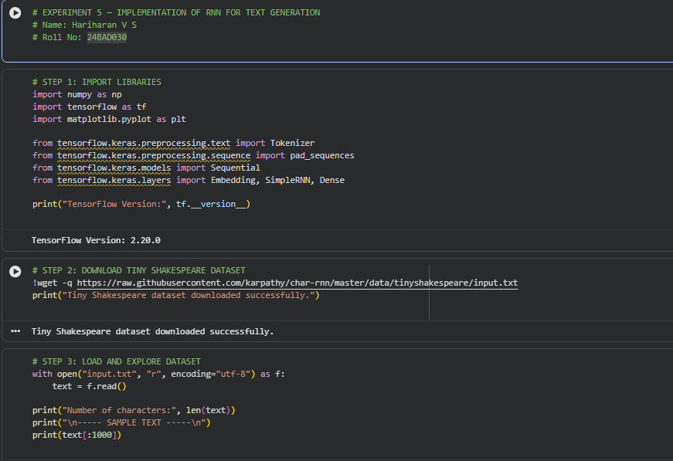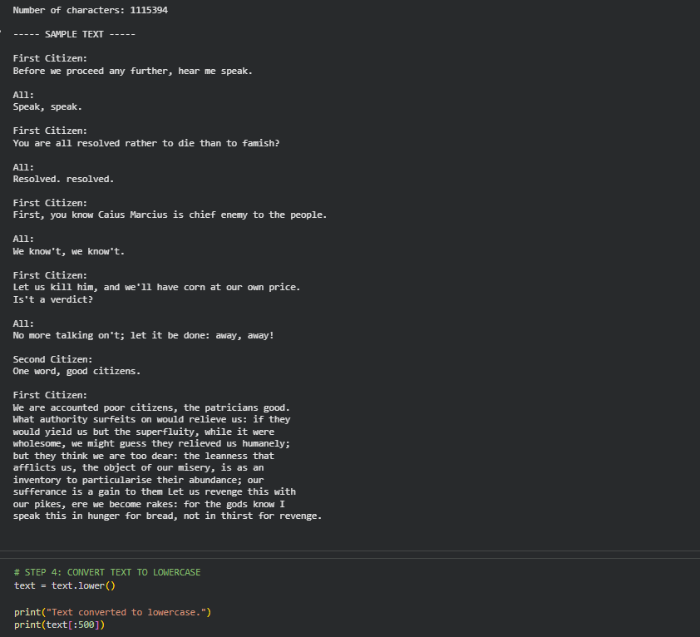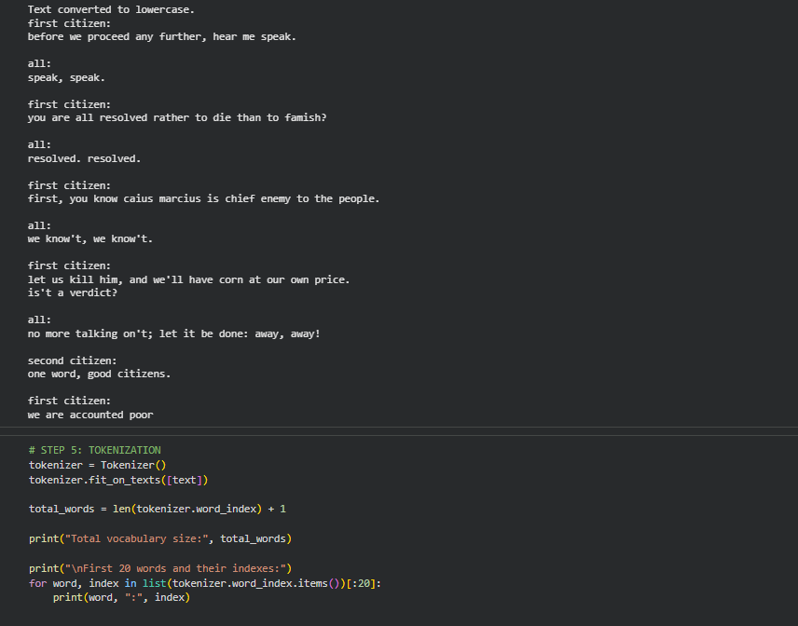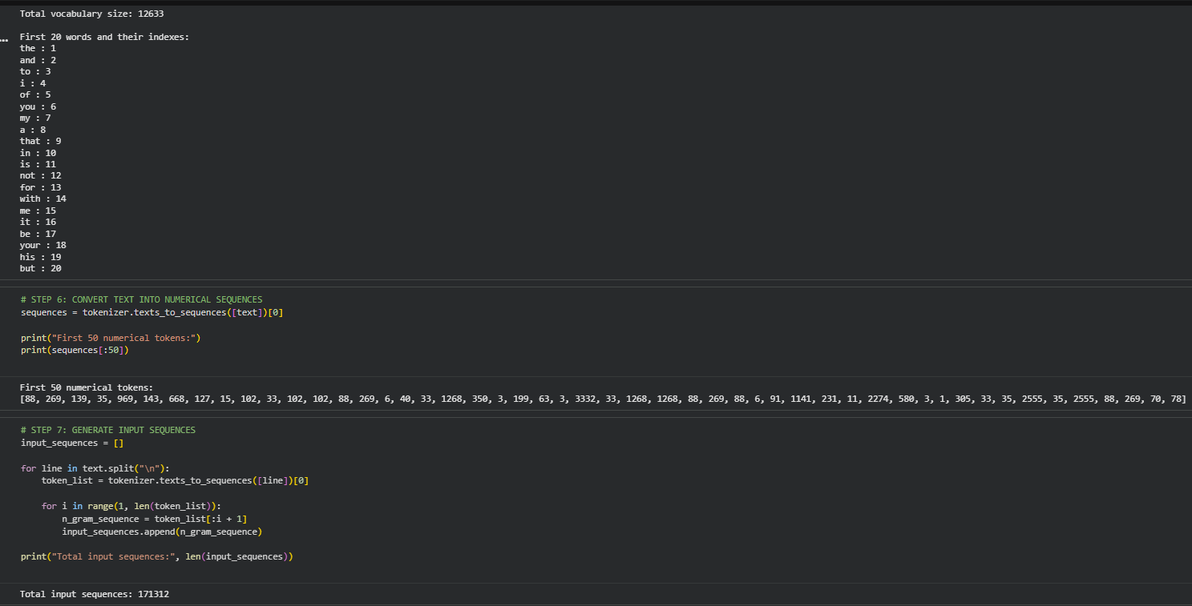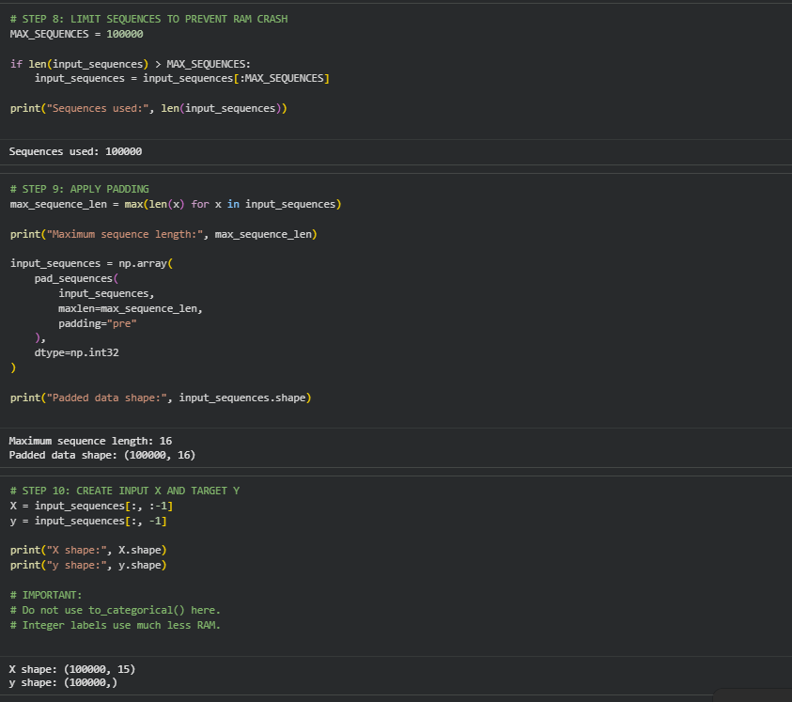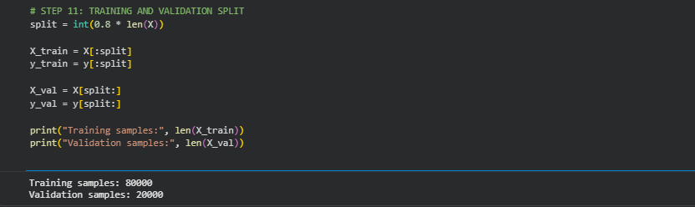

PART B: IMPLEMENTING THE RNN MODEL
Perform the following tasks:
- Create an Embedding layer to convert words into dense vector representations.
- Add a Simple RNN layer to learn sequential dependencies in the text.
- Add a Dense output layer with Softmax activation for next-word prediction.
- Compile the model using an appropriate optimizer and loss function.
- Display the model architecture and summary.

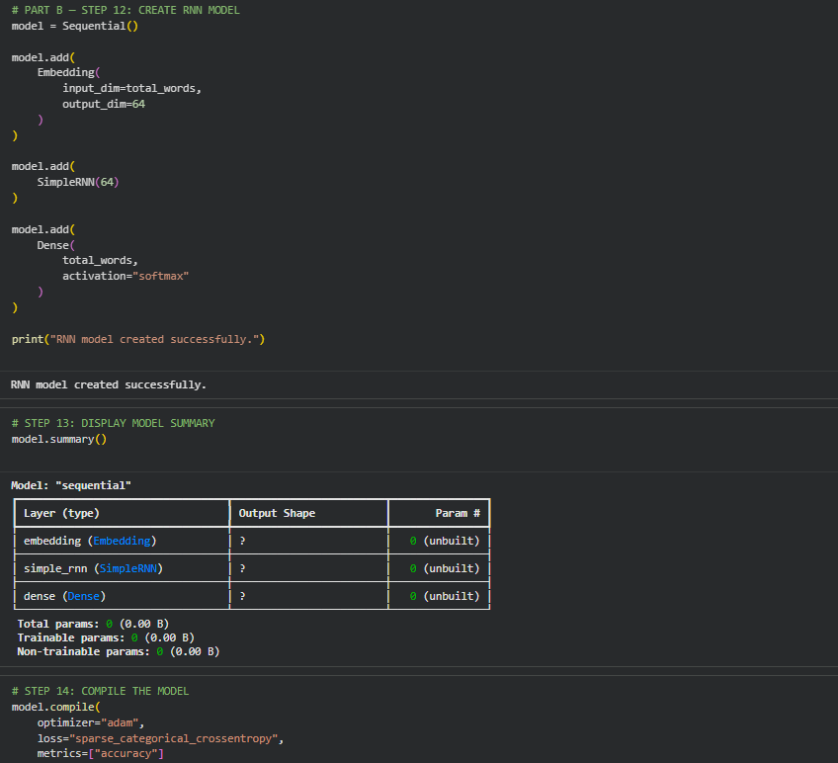

PART C: COMPARISON OF OPTIMIZATION ALGORITHMS
Perform the following tasks:
- Train the RNN model using the prepared training dataset.
- Validate the model using the validation dataset.
- Record:
  - Training accuracy
  - Validation accuracy
  - Training loss
  - Validation loss
- Visualize:
  - Accuracy vs. Epoch
  - Loss vs. Epoch

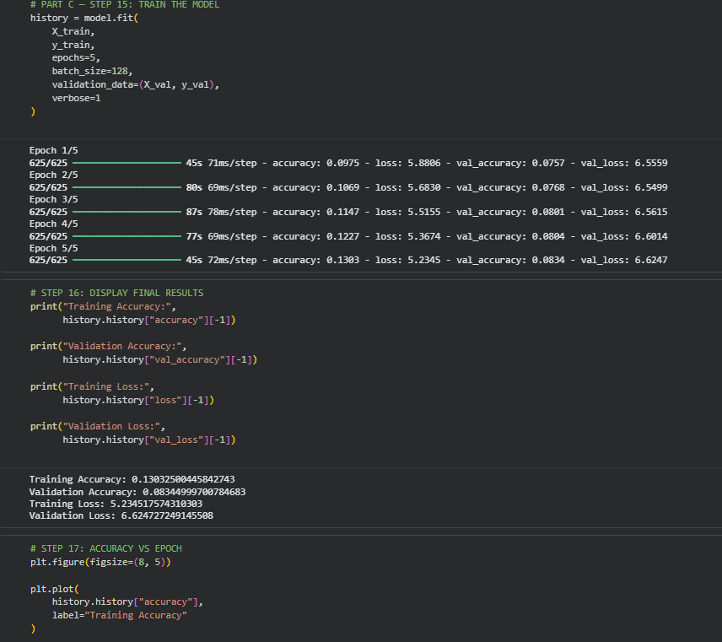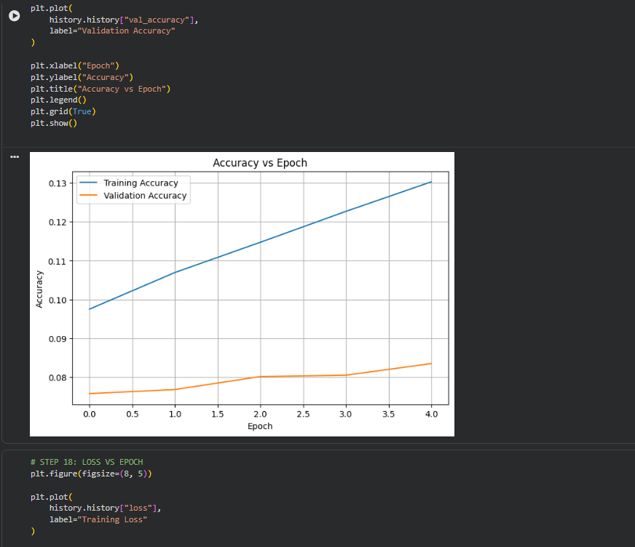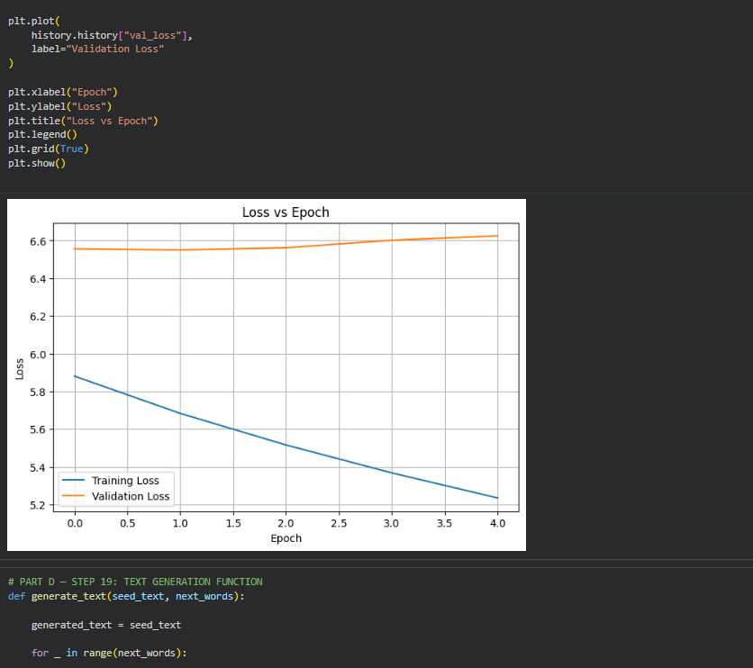

PART D: DEEP LEARNING EXPERIMENT MANAGEMENT
Perform the following tasks:
- Provide a seed word or sentence as input to the trained model.
- Generate text by repeatedly predicting the next word in the sequence.
- Produce multiple text samples using different seed inputs.
- Compare the generated text for coherence and contextual relevance.
- Document the observations and upload the notebook to GitHub.
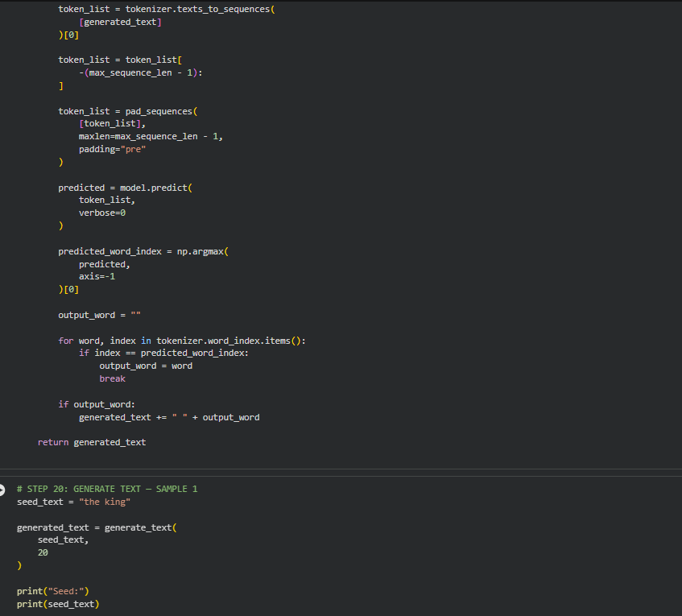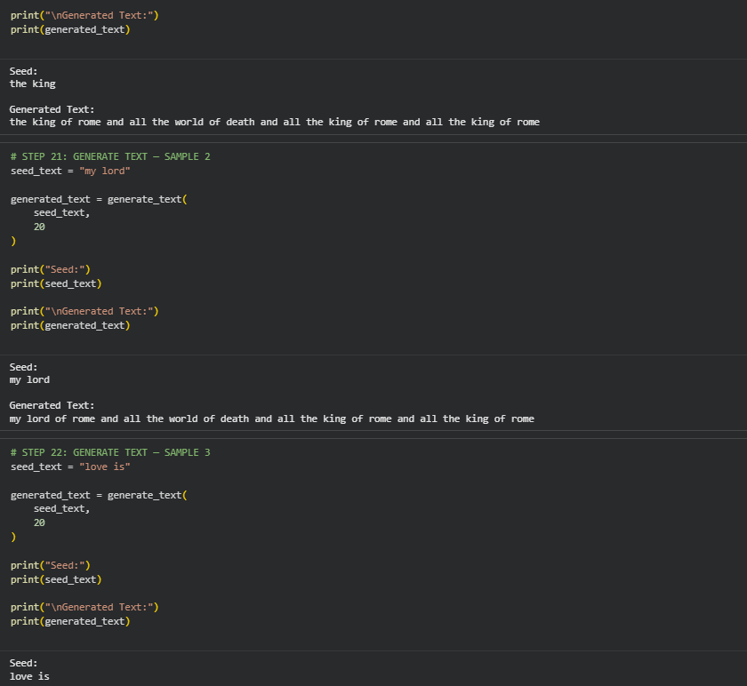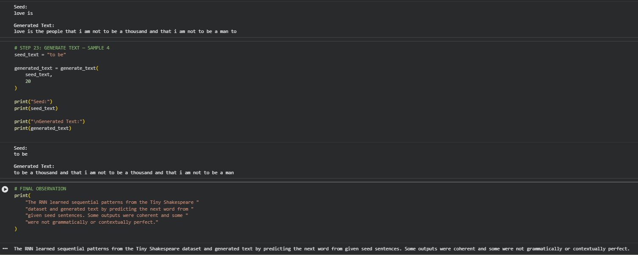

EXPECTED OUTCOME
Students will understand how an RNN learns sequential information and generates meaningful text based on previously learned patterns. Students will learn to preprocess textual data and train a Recurrent Neural Network (RNN) for text generation. They will evaluate the model's performance using training metrics and generate text through next-word prediction.

POST-LAB QUESTIONS (PROVIDE BRIEF ANSWERS TO THE FOLLOWING QUESTIONS)

- Describe the role of the hidden state in an RNN during sequence processing.
The hidden state stores information from previous inputs in the sequence. At each time step, the RNN uses the current input and the previous hidden state to produce a new hidden state.
In simple words, it acts like the memory of the RNN.
- Discuss the effect of training an RNN model for an insufficient number of epochs.

If an RNN is trained for too few epochs, the model may underfit the training data. It may not learn the important patterns and relationships between words properly.
As a result:
- Training accuracy may be low.
- Generated text may be poor or meaningless.
- The model may make incorrect predictions.

- Explain the purpose of padding when preparing text sequences for RNN training.

Padding is used to make sequences have the same length. Since sentences can contain different numbers of words, padding adds special values, usually zeros, to shorter sequences.
Example:
[1, 2, 3, 4]
[1, 2]
After padding:
[1, 2, 3, 4]
[1, 2, 0, 0]
This allows the sequences to be processed together in batches.
- Discuss one limitation of a Simple RNN when processing long text sequences.

A major limitation is the vanishing gradient problem. When processing long sequences, the RNN may have difficulty remembering information from earlier parts of the text.
Therefore, Simple RNNs may lose important long-term dependencies.

- Discuss the effect of sequence length on the performance of the text generation model.

Sequence length determines how much previous context the RNN receives.
- Short sequences: Faster training but less context, which can reduce text coherence.
- Long sequences: More context and potentially better predictions, but require more computation and may make training difficult.
Therefore, an appropriate sequence length should be selected to balance context, accuracy, and computational cost.

ASSESSMENT
Description | Max Marks | Marks Awarded
Pre Lab Exercise | 5
In Lab Exercise | 10
Post Lab Exercise | 5
Viva | 10
Total | 30
Faculty Signature

